**Excel Analytics**

***­­­­****Assignment 5.1*

You are expected to submit the steps you followed for doing all the below subtasks.

* Use the “Sales_Data.xml” file.
* Access the “xml” file in excel and save it to a comma delimited “csv” file.
* Make all the rows where “attractiveness<6” to

background colour = red, font = 8, font type = italic.

* Hide All the rows where “attractiveness<6” by using grouping. Hide in the sense, we should be able to see there is some rows there, which we can unfold to see. Also try hiding the data without grouping.
* Use the same data. The column named “attractiveness” is in general format. It is actually a rating from 1 to 10. Can you prepend “C” before the number. i.e. if it is 1, it should be converted to “C1”. Format the column to text type.

*Answers:*

1. To use the Sales_Data.xml file we can navigate to the **Data > Get External Data > From Other Sources > From XML Data Import** & locate the file stored in your machine.

2. Once the XML file is opened, we can save the file using the **Save As .CSV** from the drop down menu.

3. To make these changes we need to use the option Conditional Formatting:

Select the entire Attractiveness row and hit **Conditional Formatting > Highlight Cell Rules > Less Than**

Then in the given box we can enter 6 and in the “with” drop down menu we can select **Custom** **Format** and define the required parameters (Font = Italic; Size = 8, background colour = Red).

4. To hide the Rows using grouping, we can select the already highlighted Rows then Right-click and select **Hide**. To unhide the Rows again, we can double tap on the unfold mark or left-click and select **Unhide**.

To hide the rows without grouping we can apply **Filters** from the top ribbon or we can left-click and select the Filter option. After applying the Filter, we can select **Number Filters** from the drop down in the ‘Attractiveness’ column and select the parameter to be Greater than6.

5. To make this happen, we can create a new column equal to the length of column Attractiveness. Enter the first cell value to be C and drag it till the column’s length, this will create a new column equal to the length of Attractiveness with all the cell values as C. We can hide the column C using the aforementioned steps. After this we can simply use the function =CONCANATE (Attractiveness, C) and also press F4 key for absolute referencing. Output is displayed below:

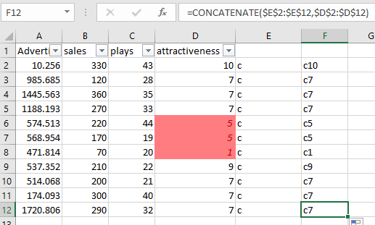

Submitted by,

Nibhir Ghosh